

Department of Electronics and Computers
Study programme: Applied Electronics

Verification Project
Control of a car lever

Table of Contents

1 Digital Circuit Project 3
1.1 Block Diagram 3
1.2 General Functionality Description of the DUT 3
1.3 DUT Interfaces 3
1.4 List of DUT Functionalities 6
1.5 Principle Schematic 7
1.6 Waveforms 7
1.7 Register Table 8
2 Verification of the Digital Circuit Project 10
2.1 Block Diagram of Project Operation 10
2.2 Verification Environment Architecture 11
2.2.1 Testbench 11
2.2.2 Environment 11
2.2.3 Generator 11
2.2.4 Mailbox 12
2.2.5 Driver 12
2.2.6 APB Input Interface Driver 12
2.2.7 Scoreboard / Reference Model 14
2.2.8 APB Monitor 14
2.2.9 Output Interface Monitor 14
2.2.10 APB Interface Transaction 14
2.2.11 Output Interface Transaction 14
2.3 List of Items to Verify 15
2.4 Functional Coverage Elements 15
2.5 Tests 16
2.6 Obtained Results 18

Digital Circuit Project
Block Diagram
Description of the General Functionality of the DUT
DUT Interfaces
List of DUT Functionalities
Principle Schematic
Waveforms
Register Table

Block Diagram

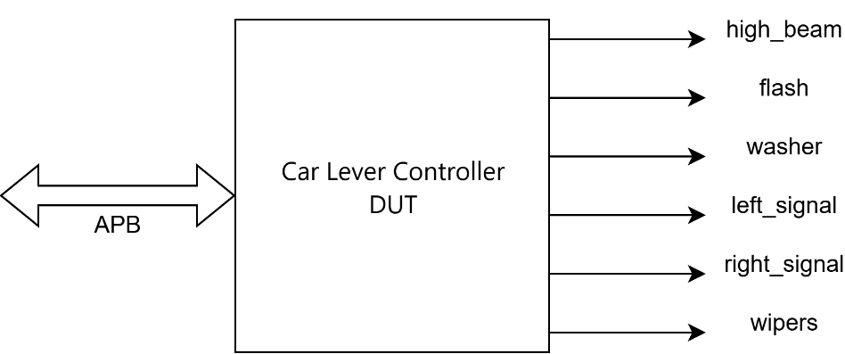
Fig 1. Block diagram of the lever control project

General Functionality Description of the DUT
The DUT receives signals from the lever through the APB interface for the functionalities of wipers, indicators, high beam, flash, and washer.
For wiper control, the DUT uses a PWM signal generated by the rain level detection sensor.The signal can correspond to the last 2 bits (LSB) from lever_reg or the data from the rain_level_reg register.

DUT Interfaces
The operation of the APB protocol is described below through the following steps:

- Transaction initialization: The process begins when the penable signal is activated. This signal indicates that a write or read transaction is to be initiated. Depending on the requirement, it will be followed by a write or read request.
- Device selection: The psel signal indicates that the desired device is selected and is ready to receive or send data.
- Addressing: While the penable signal is active, the address for writing or reading is specified on the paddr line. This address can be interpreted by the selected device.
- Operation verification: The pwrite signal specifies whether the transaction is a write (pwrite=1) or a read (pwrite=0). Based on this value, the selected device will perform the corresponding operation.
- Data handling: If the operation is a write (pwrite=1), the specified data in pwdata is sent on the data line. If the operation is a read (pwrite=0), the master will wait for the slave to send the requested data on the prdata line.
- Transaction completion and new transaction initiation: The pready signal, controlled by the Slave, indicates that the transaction is completed. This signal lasts for a single clock cycle. Once this signal has been 1, the Master can change the data on the interface to initiate the next transaction.
- Error signaling: The pslverr signal is activated by the Slave in case of an error during the transaction. This can be used to notify the Master that something did not go as planned.

For interpreting functionality, we will use the APB write protocol diagram shown below:
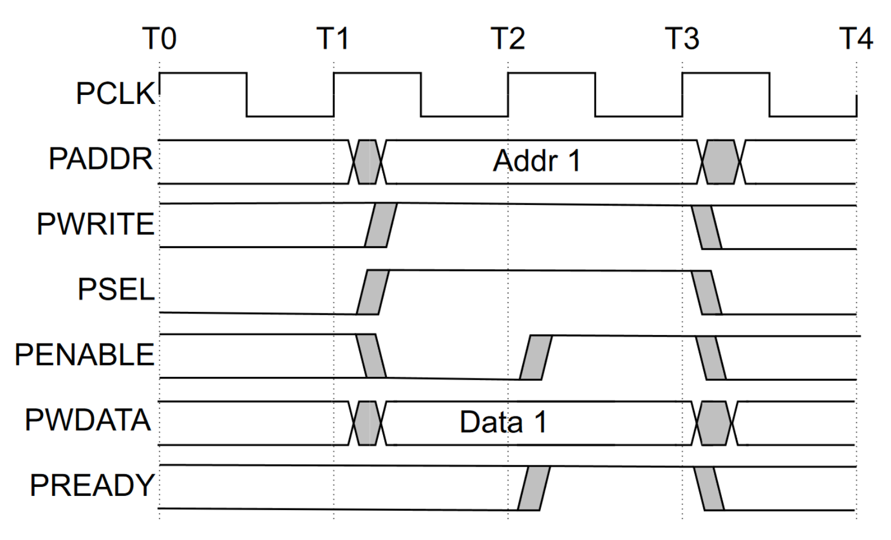
Fig.2 APB protocol functionality diagram for a write transaction

Table 1. Signals within the APB input/transmission interface to the DUT
APB Interface
Signal Name | Bit Width | Direction | Description
paddr | 2 | Input | Contains the address where writing or reading is desired
pwrite | 1 | Input | Write function used to send the specified data in pwdata on the data line
pwdata | 8 | Input | Used for storing data to be transmitted via pwrite
prdata | 8 | Output | Read function used to retrieve data from the Master
penable | 1 | Input | Alerts that the write or read process is activated; once activated, it will be followed by a write or read request
pready | 1 | Output | Signal sent by the Slave indicating if the operation has been completed and the Master can be notified to initiate the next transmission
pslverr | 1 | Output | Signal sent by the Slave when an error occurs during the transaction
psel | 1 | Input | Checks that the device is selected and indicates whether it is ready to receive or send data

Table 2. Signals within the DUT output interface
Output Interface
Signal Name | Bit Width | Direction | Description
wipers | 1 | Output | Controls wipers through a PWM signal
high_beam | 1 | Output | Turns on the high beam
flash | 1 | Output | Turns on the flash and turns it off after 3 clock cycles
washer | 1 | Output | Controls the windshield washer activation and deactivation
right_signal | 1 | Output | Turns on the right indicator
left_signal | 1 | Output | Turns on the left indicator

List of DUT Functionalities
The DUT responds to requests on the APB interface as soon as they appear.
The DUT receives data appearing on APB in lever_reg for controlling each function individually and responds to requests on this interface immediately.
For this DUT, the reset signal is active high.After setting bit 5 of the lever_reg register to 1, the flash signal becomes 1 for 3 cycles and then goes back to 0. Also, bit 5 in lever_reg is automatically cleared after the first clock cycle once the flash signal becomes 1.
The register containing the signals for the lever's functionality is presented below:
For wiper control, a PWM signal based on the rain_level_reg register will be used. The connection between this register and the control bits in lever_reg for the wipers involves assigning a specific PWM level based on the rain level, which then determines the wiper operation. For example:
For rain_level_reg between 0 and 45, the PWM duty cycle will be 0%, meaning that when the rain level is within this range, the wiper will be assigned 00 – off.
The following table represents the relationship between rain_level_reg and PWM for wiper control in lever_reg:
rain_level_reg (for automatic mode) | PWM | Wipers – bit code (for manual mode)
0 – 44 | 0% | 00
45 – 124 | 25% | 01
125 – 214 | 75% | 10
215 – 255 | 100% | 11
Table 1. Reference table for wiper control using PWM.

Principle Schematic
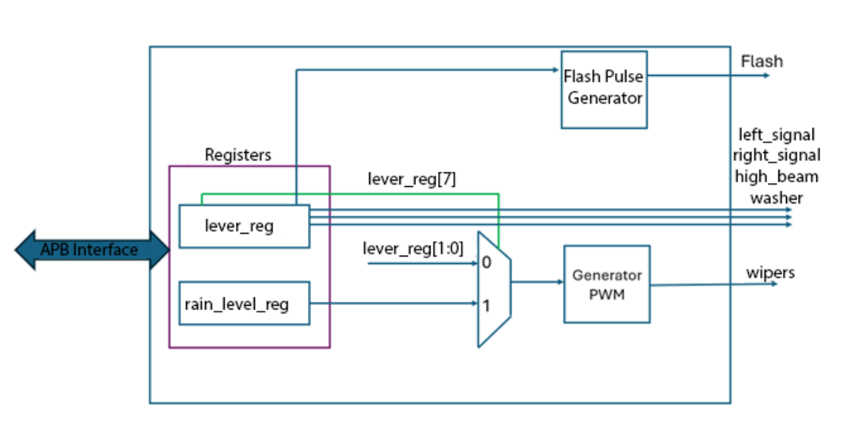

Fig 3. DUT Block Diagram

Waveforms
The operation of protocols used on interfaces will be described using waveforms (separate waveforms will be provided for different protocol operation aspects: read access, write access). To draw waveforms, the website WaveDrom can be used.
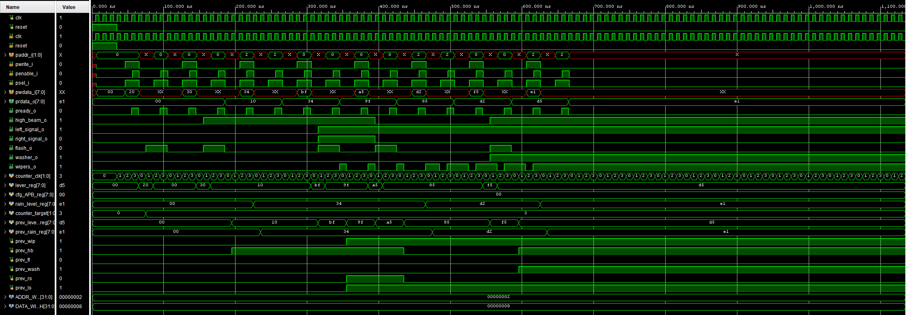
Figure 4. Vivado DUT waveforms

Register Table
Table 4. Register table accessible by the DUT.
Register Name | Access Address | Register Structure | Description of Register Fields
lever_reg | 0x00 | 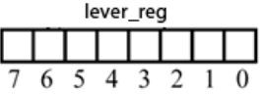 | lever_reg contains:  wiper control functionality: wipers [bits 1:0]  left turn signal control: left_signal [bit 2]  right turn signal control: right_signal [bit 3]  continuous high beam enable/disable: high_beam [bit 4]  flash enable/disable (briefly turns on high beam): flash [bit 5]  washer activation functionality: washer [bit 6]  Wiper mode can be automatic (corresponding to bit 7 value "1") or manual (when bit 7 value is "0")
cfg_APB_reg | 0x01 | 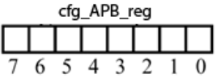 | Memory function register
rain_level_reg | 0x02 | 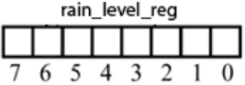 | Stores the rain level with values between 0-255

Verification of the Digital Circuit Project
Block diagram of project operation
Verification environment architecture
List of elements to be verified
Functional coverage elements
Tests
Obtained results

Block Diagram of Project Operation

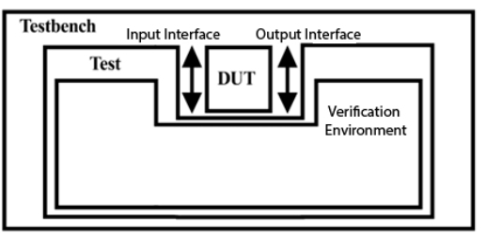
Figure 5. Project file structure

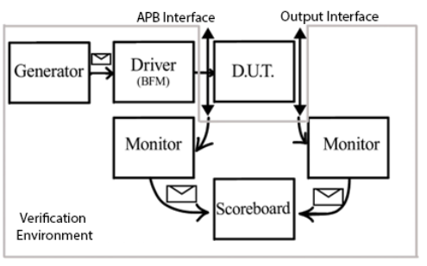
` Figure 6. Block diagram of project operation

Verification Environment Architecture
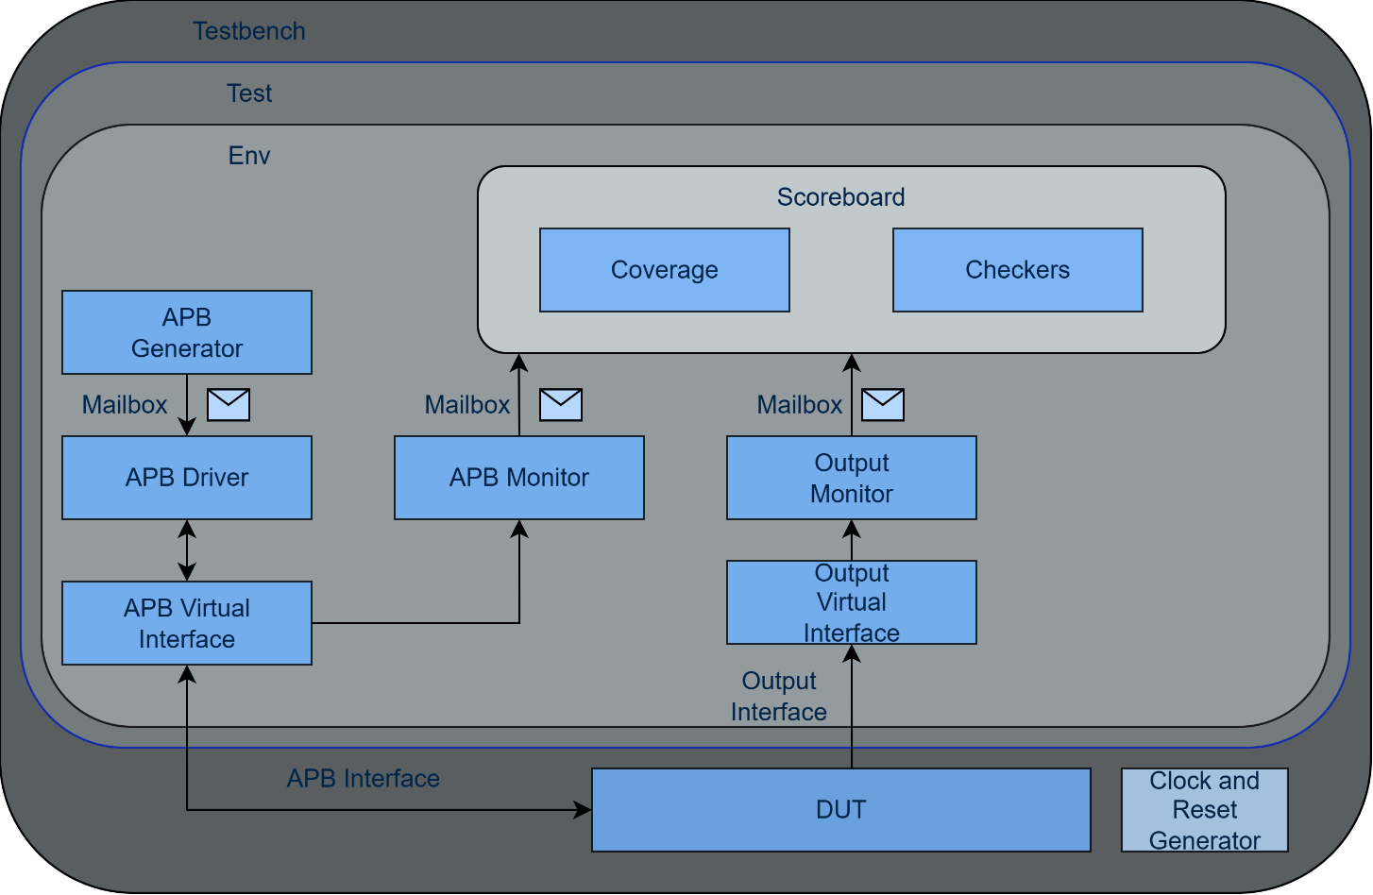
Figure 7. Overview of the components necessary for sending stimuli to the DUT via the APB interface

Testbench
The testbench is the central component of the verification environment. It is a separate Verilog module that contains the necessary logic to configure and control the unit under test (DUT). Ideally, the testbench simulates the environment in which the design will operate, generating input signals and comparing the results with expected values. It may also include functionalities such as stimulus generation, monitoring, and test result reporting.

Environment
The verification environment includes a module responsible for managing the settings and configurations required for testing. This module may handle parameter initialization, timing control, and the generation of environmental conditions necessary for verification.

Generator
The generator is responsible for producing stimuli for the design under test. It can generate different types of signals, such as pulses, random values, or data sequences, to evaluate the design's behavior and performance.

Mailbox
The mailbox acts as an interface between the generator and the driver, as well as between the driver and the monitor. It is used to transfer data between these modules and to coordinate communication within the verification environment.

Driver
The driver is responsible for transmitting input signals to the design under test. It receives the generated data and translates them into control signals and specific data for the DUT. Additionally, it can monitor and respond to feedback from the DUT, reporting the test results back to the testbench.

APB Input Interface Driver

Figure 8. APB Write Functionality

- Transaction initialization: The process begins when the penable signal is activated. This signal indicates the start of a read or write transaction. Depending on the operation, a read or write request follows.
- Device selection (peripheral): The psel signal indicates that the desired device is selected and ready to send or receive data.
- Addressing: While the penable signal is active, the target address for the read or write operation is specified on the paddr line. The selected device interprets this address.
- Operation verification: The pwrite signal specifies whether the transaction is a write (pwrite=1) or a read (pwrite=0). Based on this value, the selected device executes the corresponding operation.
- Data transmission: If the operation is a write (pwrite=1), the data of the specified size in pwdata is transmitted over the data bus. For a read operation (pwrite=0), the master waits for the slave to send the requested data on the prdata line.
- Transaction completion and initiation of a new transaction: The pready signal, controlled by the slave, indicates that the transaction is complete. This signal lasts for a single clock cycle. Once this signal is asserted (pready=1), the master can update the data on the interface to start the next transaction.
- Error signaling: The pslverr signal is activated by the slave in case of an error during the transaction. It is used to notify the master that an issue has occurred.
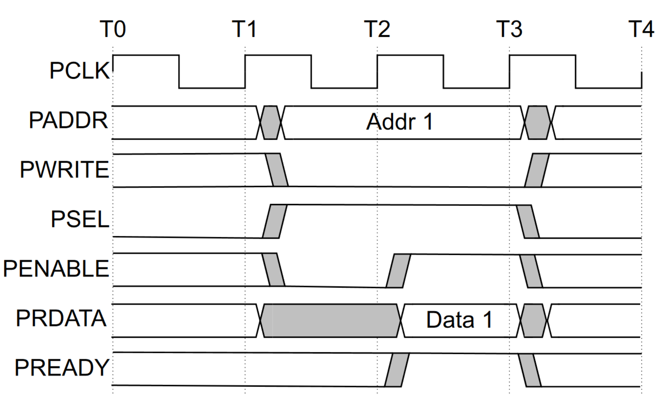
Figure 9. APB Read Functionality

The process for output reading using APB functionality is as follows:
- Transaction initialization: The process starts when the penable signal is activated, indicating a read transaction request to obtain data from an external device or another peripheral.
- Device selection (peripheral): The psel signal indicates that the desired device is selected and ready to send the requested data.
- Addressing: While the penable signal is active, the address from which data is requested is specified on the paddr line. The selected device interprets this address to determine the data location.
- Operation verification: The pwrite signal specifies that the transaction is a read (pwrite=0), confirming that data retrieval from the selected device is required.
- Data transmission: The master waits for the external device or peripheral to send the requested data on the prdata line. These data are then read and interpreted by the master.
- Transaction completion: The pready signal, controlled by the slave, indicates that the transaction is complete. This signal lasts for a single clock cycle. Once activated, the master can proceed with processing or utilizing the read data.

Scoreboard / Reference Model
The scoreboard ensures that the DUT functions correctly by receiving the same signals from both the input monitor and output monitor and verifying that the response matches the expected DUT output.

APB Monitor
The APB Monitor observes traffic on the APB input interface by sampling signals at each clock edge when pready is asserted. It captures the address, write_enable, and data fields from the interface, reconstructs them into an apb_transaction object, and forwards it to the scoreboard via a mailbox for verification. It also triggers the APB coverage collector to sample each completed transaction.

Output Interface Monitor
The Output Interface Monitor observes the DUT's output signals (wipers, high_beam, flash, washer, right_signal, left_signal) by sampling them at each clock edge. It detects transitions on these signals, reconstructs the captured values into an out_transaction object, and sends it to the scoreboard via a mailbox. It also triggers the output coverage collector to sample each observed output state.

APB Interface Transaction
The APB Interface Transaction (apb_transaction class) defines the data structure used to exchange information between the generator, driver, monitor, and scoreboard for the APB interface. It contains the following fields: address (2-bit register address), write_enable (1 for write, 0 for read), data (8-bit data value), delay (random inter-transaction delay of 0-30 clock cycles), and transaction_number (sequential counter). The class includes a do_copy() method for deep copying transaction objects.

Output Interface Transaction
The Output Interface Transaction (out_transaction class) defines the data structure used to capture and exchange DUT output state within the verification environment. It contains the following fields: wipers, high_beam, washer, flash, right_signal, and left_signal — each a 1-bit signal representing the corresponding DUT output. The class includes a do_copy() method for deep copying transaction objects.

List of Items to Verify
This section describes how to verify that the DUT functions correctly.
The verification elements (checkers) will be organized by interfaces.
Checker | Description
psel_and_penable_active | This assertion checks if the psel and penable signals are active at the same time within a clock cycle. It is defined as a property object that needs to be verified. This assertion is activated at every clock edge (posedge clk), but it is disabled during reset operations (disable iff(reset)). The assertion content indicates that psel must become active ($rose(psel)) and, in the next clock cycle (##1), penable must also become active ($rose(penable)).
pready_after_psel_falls | This assertion checks if the pready signal becomes inactive after the psel signal becomes inactive. It is defined similarly to the previous assertion, with the difference that it verifies a negative transition (fell) for both the psel and pready signals. The assertion is activated at every clock edge and is disabled during reset operations.
penable_after_psel_falls | This assertion checks if the penable signal becomes inactive after the psel signal becomes inactive. It is defined similarly to the previous assertion, with the difference that it verifies a negative transition for both the psel and penable signals.
pwdata_activate_at_psel_and_pwrite | This assertion checks if the pwdata signal remains stable after the psel, pwrite, and penable signals become active in the same clock cycle. It is defined similarly to the other assertions, with the difference that it verifies the stability of the pwdata signal ($stable(pwdata)) after the simultaneous activation of the psel, pwrite, and penable signals.

Functional Coverage Elements
The coverage elements can be listed as a table (each coverage group in a separate table). They will also be organized by interfaces.

Event: cover_trans_done_ev: triggered at the end of a burst transaction.
Cover Point | Description
wr_enable_cp | The write_enable field from APB transactions is recorded. For 100% coverage, this field must have both values 0 and 1 during the simulation.
address_cp | The entire address range has been covered. The addresses are 2-bit wide, so there are a maximum of 4 combinations.
data_cp | The following values are recorded: the minimum (0), maximum (255), and at least one value from each of 4 sub-intervals within the 0-255 range.

Tests
Table 5: List of implemented tests for DUT verification

Test File  Name | Test Description
test_register_access.sv | This test starts the high beam and washer functions and verifies that they activate simultaneously (i.e., transition from 0 to 1) one clock cycle after the pready signal goes to 1.
test_registers.sv | This test verifies the correct functionality for random values obtained using $random, followed by assigning the values 10101010 and 01010101 to the lever_reg and rain_level_reg registers. It also verifies that when a bit in a register is assigned the value 1 (activated), it transitions to 1 and then back to 0.
test_left_signal.sv | This test verifies the left turn signal functionality by controlling the left_signal_o bit. It ensures correct operation according to the APB protocol.
test_right_signal.sv | This test verifies the right turn signal functionality by assigning the right_signal_o bit a value of 1. It also verifies the proper functionality of the integrated APB protocol.
test_hazard.sv | This test verifies the hazard light functionality, ensuring both turn signals blink simultaneously. The expected behavior is for both right_signal and left_signal to be 1 and toggle between 0 and 1 at a fixed interval.
test_wipers.sv | This test verifies the functionality of the windshield wipers in manual mode—meaning that rain_level_reg does not influence their speed. The waveforms are tested for the MSB 10 position (moderate rain mode).
test_washer.sv | This test verifies the sprayer functionality. The expected behavior is that it should be 1 for only a few clock cycles to create a spraying effect, rather than continuous spraying.
test_high_beam.sv | This test verifies the high beam functionality.
test_flash.sv | This test verifies the flash functionality. The expected behavior is that the signal is active only while the lever is pressed, making the duration user-dependent. After setting bit 5 in the lever_reg register to 1, the flash signal remains 1 for 3 clock cycles before returning to 0. Also, bit 5 in lever_reg is automatically cleared one clock cycle after flash is activated.
test_flash_highbeam.sv | This test verifies the simultaneous activation of high beams and flash.
test_wipers_washer.sv | This test verifies the simultaneous functionality of windshield wipers and sprayer.
test_wipers_25.sv | This test verifies the automatic windshield wiper functionality when rain_level_reg is in the 44-124 range, corresponding to a PWM of 25%.
test_wipers_75.sv | This test verifies the automatic windshield wiper functionality when rain_level_reg is in the 125-214 range, corresponding to a PWM of 75%.
test_wipers_100.sv | This test verifies the automatic windshield wiper functionality when rain_level_reg is in the 215-255 range, corresponding to a PWM of 100%.
test_wipers_0.sv | This test verifies the automatic windshield wiper functionality when rain_level_reg is in the 0-44 range, corresponding to a PWM of 0%.
test_combined.sv | This test verifies the overall functionality of the DUT, ensuring it responds correctly to all commands issued simultaneously.

Obtained Results
Following the execution of the test_combined.sv test, the simulation completed successfully with all 16 APB transactions processed correctly. The functional coverage achieved 100% for all defined coverpoints: write_enable (both read and write operations), address (all 4 register addresses accessed), and data (minimum, maximum, and values from each sub-interval covered). All DUT functionalities, wipers (manual and automatic modes with PWM duty cycles of 0%, 25%, 75%, and 100%), high beam, flash (3-cycle pulse with auto-clear), washer, left turn signal, right turn signal, and hazard lights, were verified to operate correctly according to the specification.

